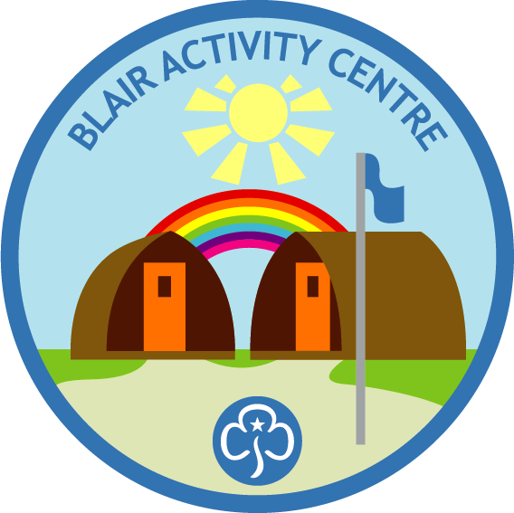
Blair Activity Centre – Check Out List
Please bring a copy of this check list with you. Once completed leave on kitchen worktop in the relevant building, Chalet or Hall

Tasks | Chalet | Hall
Toilets and Showers
Toilets and sinks cleaned, floors swept and mopped.
Showers cleaned, floors swept and mopped. |  | N/A
The sanitary bins are emptied
Kitchen
All food must be removed from the cupboards, fridge and freezers, nothing should be left on site.
Fridge and freezers to be cleaned out, switched off and the door to be left open.
Cooker, sink and work surface all to be wiped down and cleaned.
All sockets to be switched off
Cutlery, crockery and all cooking implements to be cleaned and returned to cupboards and draws tidily.
All bins to be emptied and wiped out.
Kitchen floor to be swept and mopped.
Communal Spaces
Floors to be swept and mopped
All bins to be emptied
Ensure all lights are switched off, inside and outside
Heating and all heaters are switched off
Main Electrical Switch off in the Chalet |  | N/A
Rubbish
All bins to be emptied and all rubbish to be removed from site.
There is no rubbish collection for the site so please take it all home with you.
Equipment
Return outdoor games and equipment to where it came from.
All activity equipment clean and back in the Chalet.
Cover replaced on motor of the Bungee Trampoline
Locking Up
Check all doors are locked, Wigwams, Our Chalet and the Hall.(depending on use)
Lock doors and return the key to the relevant KEY SAFE, set code to 0000
Close and lock the padlock on the inner gate
Return the signs to inside the outer gate
Close the outer gates
Please remove any item/s used for directions for the road end.

Wigwams (if applicable) | Done
Wipe down surfaces and sweep the floor
All rubbish removed
Return seats to seating position
Electric Heater switched off
Lock the door and return the key to the key box in the Chalet.

Tents (if applicable) | Done
In event of a wet strike, drape tents over the tables and chairs in the Chalet. When the tents are dry, they can then be folded and return to the racks. If they are not dry, come back the following evening to fold and store or contact your allotted contact for advice.
Tidy campsite and check no food stuff has been left
Please clean and dry all other camping equipment used, ie basins, buckets, water carriers etc.
Outdoor sinks to be left clean and tidy, all rubbish removed.

Please leave a note of all breakages; damages, incidents and accidents in the centre log books, one found in Chalet and one in the hall. Please record anything your notice on your arrival or made during your stay.
Please let us know of any additional information you would like to share with us.

Signature of Leader-in-Charge
Date

